Free Youtube views for an unlimited number of your videos! Boost your video's popularity using their simple and free method! Or, buy Youtube views and other services here.

[ythunder.com](https://ythunder.com/) has free & open registrations.

No matter how thoughtful, helpful, educational, or just plain inoffensive your content is, there will always be someone announcing their less-than-positive opinion or reaching out with hateful words. While this can become disheartening for new creators, it’s an unfortunate reality for anyone putting Free Youtube views：[ythunder.com](https://ythunder.com/)

their work out into the world. Even offline criticism is common, and it can sometimes sting. So what separates success from failure? It’s all about how you choose to handle the hate! Here at ythunder we know how much work you put in to your content, that’s why we’ve put together a few tips on how to respond to negative feedback and criticism online.

**Step One: Relax**Free Youtube views：[ythunder.com](https://ythunder.com/)



While it’s tempting to respond to negative feedback with a few choice words of your own, responding to negativity with more negativity results in, well...more negativity. Starting an all-out battle of words and wits online will only result in your temper being advertised in a public space, and your attacker will use this to their advantage. Take a few deep breaths, and return to the comment or message in a few minutes after completing step two.

**Step Two: Reflect**



Instead of reacting immediately, take a few minutes to pause and reflect on the comment. It’s important to understand the criticism fully before taking any action, in order to prevent further conflict or easily avoidable mistakes. Here are a few questions you can ask yourself:

* Is this true? If so, what can I do to make it better?
* Is this offensive, threatening, or just plain spam?
* Is the person behind the comment a customer, viewer, or follower? Or are they just a random troll?

In order to react constructively, you need to know several things:

* Why am I receiving this comment or message?
* Who has written this?
* What error or flaw are they addressing?
* How can I improve their experience or my content?

Once you have the answers to these questions, you’re ready to move on to step three.

**Step Three: Respond**

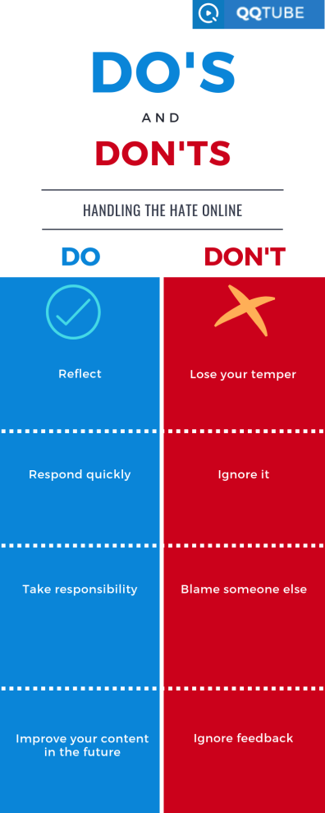

No matter what the comment says, or who it’s from, it’s important to respond in order to set things straight for both the user, and anyone else who comes across the comment. If they see you ignored a fake negative comment, they might believe it! However, if you take the time to address the comment your prospective followers will feel better about dedicating their time to your brand or product. Here’s what you should do for all negative messages, comments, or reviews:

* + Address the issue and apologize for their dissatisfaction.
  + If their criticism is fake, address it calmly by providing them with the facts.
  + If their criticism or complain is true, assure them that it won’t happen again and offer to solve the issue.
  + Keep the lines of communication open. Tell them that they’re welcome to provide you with further recommendations on how to improve in the future.
* ***If the comment is offensive, spam, or fake, make sure you flag it as such or report it to the correct department within your social media platform or review site.***

**Step Four: Reevaluate**



Even negative remarks can sometimes hold an ounce of truth. Maybe your critic wasn’t the nicest, but if a viewer or customer has something negative to say, it’s always worth reflecting on in order to improve your content or product moving forward. However, don’t let every recommendation take up your time; if you know something is unreasonable, impossible, or just plain irrelevant, there’s no need to lose sleep worrying about how to please them.

***As always, the team here at ythunder knows how much time and effort goes into creating the content that matters the most. That’s why we curate weekly content to help you improve your marketing campaigns, build your brand, and increase engagement. Visit our Services & Pricing page to see our updated offers, and start building a foundation for your brand today!***Free Youtube views for an unlimited number of your videos! Boost your video's popularity using their simple and free method! Or, buy Youtube views and other services here.

[ythunder.com](https://ythunder.com/) has free & open registrations.